Day -2 : DHCP Configuration

1. Setting up DHCP with two client PC’s :
1.Place the Network Devices:Topology Setup.
Drag and drop 1 Server (Generic Server) and 2 PCs (PC0 and PC1) into the logical workspace. Connect all three devices using Copper Straight-Through cables to a Central Switch (e.g., 2960 Switch).
2.Configure Static IP on the DHCP Server:Prerequisite.
Click on the Server and navigate to Desktop > IP Configuration. Assign a static IP address to the server interface (e.g., IP: 192.168.1.1, Subnet Mask: 255.255.255.0).
3.Configure the DHCP Service:Service Setup.
Go to the Services tab on the Server and select DHCP:
- Set the Service toggle to On.
- Set Start IP Address to 192.168.1.10.
- Set Maximum number of Users to 50.
- Click Save.
4.Set Client PCs to DHCP:Client Configuration.
Click on PC0, go to Desktop > IP Configuration, and select the DHCP radio button. Repeat this step for PC1.
5.Verify Assigned IP Addresses:Verification.
Observe the output under IP Configuration. PC0 will receive 192.168.1.10 and PC1 will receive 192.168.1.11 (or vice versa), confirming that the server automatically distributed unique IP addresses from the pool.

2. DHCP Process :

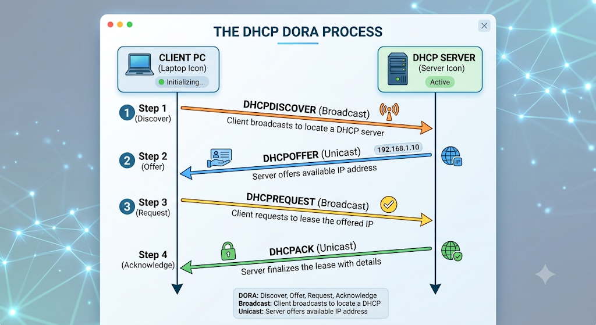

3. Single IP Pool Test :
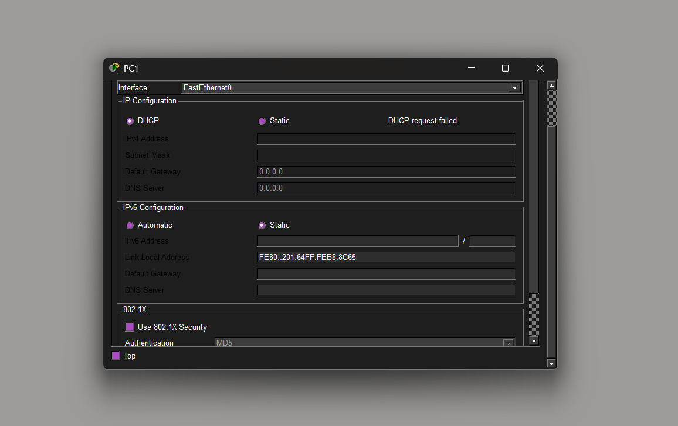

4. Zomato style Setup :

- Add a Wireless Router (or Access Point connected to a DHCP Server).
- Connect a Laptop (Billing Terminal) and a PC renamed to Smartphone (Customer Device) via Wi-Fi or FastEthernet to the network.
- Configure the wireless router's built-in DHCP pool to assign addresses automatically.
Results
- Laptop: Obtains IP 192.168.0.100 via DHCP.
- Smartphone: Obtains IP 192.168.0.101 via DHCP.
Why DHCP is Useful Here
In a busy restaurant, hundreds of customers and staff devices join and leave the network continuously throughout the day. DHCP automatically handles giving every incoming phone or laptop a temporary IP address without requiring the manager or barista to type in manual network configurations for every single customer.

